**Swami Vivekananda and the Vedanta Philosophy**

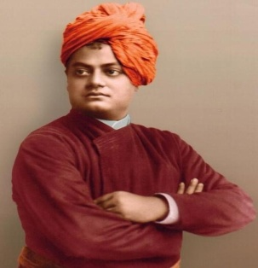

**Swami Vivekananda**

**Introduction to Swami Vivekananda**

* Born in Kolkata on January 12, 1863.
* Birth name: Narendranatha Dutta.
* Guru: Ramakrishna Paramahansa
* Died: 4 July 1902 (aged 39) near Kolkata
* Swami Vivekananda was attracted to the religious books of India since he was little.
* He claimed that his meeting with Ramakrishna was a turning point in his life.
* After the death of Ramakrishna, he traveled all around India to study other cultures.
* He then traveled to Japan and America.
* He was the first Hindu missionary to go to the west and he represented Hinduism at the parliament of religions in America in 1893. He then gave his famous speech which began with “Sisters and brothers of America”.
* He returned to India and founded the Ramakrishna Mission—the organization for social service.
* He then visited California and founded Shanti Ashrama.
* He died at the age of 39, and that fulfilled his prophecy that stated that he was going to die before he turned 40.

**Swami Vivekananda's contributions to Hinduism**

* Swamiji gave Hinduism a proper identity.
* Before Swamiji, the west had a poor view of Hinduism as a religion of superstitions. He helped change this view.
* According to him, religion has an essential inner core (spirituality) and non essential outer core (rituals, beliefs, and customs). Swamiji showed that in the realm of spirituality, Hinduism is quite superior and is based on eternal truths and laws.
* There were several sects of Hinduism, each claiming superior over the others.
* He united all of the sects by reminding them of their common heritage.
* He accepted the whole of the Vedas, the gyan kanda and the karma kanda, the puranas, and the itihas, all myths and legends, and tried to preserve them.

**The Vedanta Philosophy**

* Philosophy created by Vivekananda
* Vedanta: Eternal spiritual truths recorded in the Upanishads States that:
  + Each soul is potentially divine.
  + The goal is to manifest this Divinity within by controlling nature, external and internal.
  + Do this either by work, or worship, or mental discipline, or philosophy—by one, or more, or all of these—and be free.
  + This is the whole of religion. Doctrines, or dogmas, or rituals, or books, or temples, or forms, are but secondary details.
* He popularized yoga as the practical aspect of Vedanta.

**Importance of Vedas and Upanishads**

* He spread awareness and importance of **Vedas** and **Upanishads** – records of eternal truths and laws of the spiritual world, discovered by ancient Indian sages.
* He explained why Upanishads are regarded as the highest authority in spiritualism
* He showed how Upanishads compliment modern science.
* He explained Upanishads in a way that common people can understand.
* He said that these books not only help you attain Mukti but can also help you with everyday problems.

**Swami Vivekananda taught people that the Vedas can help you with everyday life.**