**GAYATRI GYAN KENDRA OF LONG ISLAND**

**GROUP 5 AND 6**

**September 23, 2012**

**Yagna**

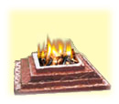

* *Yagna* means selfless sacrifice for noble purposes; Sacrificing the ego, selfishness and material attachments.
* *Yagna* teaches living in a society in harmony and a lifestyle to promote and protect higher humane values in the society.
* **Yagna comprises of three elements:**
* Worship of Gods - Appreciating noble qualities
* Togetherness - Unity
* Charity - Welfare/Donation

**Types of Yagna**

* *SevaYagna-* altruist service of the society
* *GnanaYagna-* service of people by enlightening their lives in the glow of knowledge and education

*PramaYagna-* saving the lives of people suffering and in agony and inspiring liveliness and respect for life in them.

**The Philosophy of Yagya**

The Ocean gives its water to the clouds. Clouds carry and pour then as rain. Rain fed soils and rivers and in turn return to ocean. Each part of body constantly working for the well-being of the whole body.

The real purpose of Yajna is to imbibe virtues like self-sacrifice, self-restraint (sanyam), charity, beneficence, generosity, compassion etc. in our daily life. It inspires us to surrender everything, body, mind, ego and soul to God.The real Yagya is to follow the directions and inspirations of our indwelling divinity and imbibe righteous tendencies. Constant remembrance of the Divine, keeping an attitude of detachment and remaining engrossed in regular sacred studies and devotion amounts to leading a Yagyiya life.

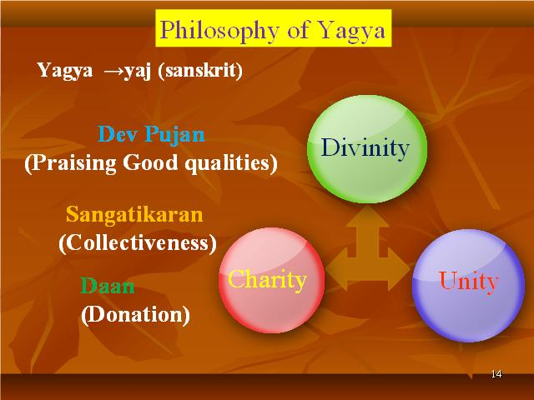

**THE BUILDING BLOCKS OF THE HUMAN CULTURE AND CIVILIZATION**

Gayatri encompasses the original knowledge part of existence, expansion and evolution of the cosmos.

Yagna deals with the corresponding domains of creativity and actions.

They directly impact the physical, mental and spiritualdevelopment of human life, as well as the principles and practices of the fundamental components of the ancient Indian culture.

Pt. Shri Ram Sharma Acharya significantly roused the Indian Cultural values and implemented the practices of Gayatri and Yagna as scientific experiments aimed at the welfare of all living

beings.

**Things Used in Yagna**

* *Wood-* sandalwood, pipal, mangoHavankund



* *Odoriferous Substances-* saffron, musk, camphor
* *Substances with Healthy Constituents-* milk, clarified butter, fruit, & grains such as rice
* *Sweet Substances-* sugar, dried grapes, honey
* *Medicinal Herbs-* somalata, brahmi, shankhpushpi, nagkesar, mulhati

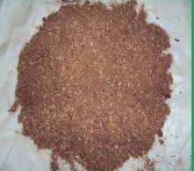

**THE INVERTED PYRAMID SHAPED KUNDA**

• The ancient word pyramid means “fire in the middle” and is closely connected with energies emanating from its central shape.

• The inverted pyramid shape of the Agni kunda allows for the generation and multidirectional dissipation of energy.

• The dimensions of the copper pot used for the daily Agnihotra are: 14.5 cm × 14.5 cm at the top, 5.25 cm × 5.25 cm at the bottom and 6.5 cm in height with three steps.

• The inverted pyramid shaped Agnihotra pot receives, generates and decentralizes and acts as an effective bacteriostatic and antimicrobial reactor.

**Science and Yagna**

* Industrial wastes, rapid urbanization, deforestation, air and water pollution, disturbances in the ozone layer formation, and radioactive waves have destabilized the human, animal and plant life cycles. The ecological imbalances caused by these acts of ‘civilized men’ has resulted into a disastrous threat to the entire planet.
* Experimental studies show that the incidence of physical ailments, sickness and disease are reduced in the houses where the *Yagna* (Agnihotra) is regularly performed because it creates a pure, nutritional and medicinal atmosphere. It renews the brain cells, revitalizes the skin, purifies blood and prevents the growth of pathogenic organisms.

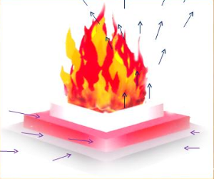

* Cow’s milk contains great power of protection from atomic  radiation
* If cow’s ghee is put into the *Yagna* fire, its fumes lessen the effect of atomic radiation to a great extent.
* Removes foul odors- Various oils such as camphor and clove diffuse into the atmosphere
* Removes bacteria- The oxidation of hydrocarbons during *Yagna* produces              formic acid and acetic acid, both of which are good disinfectants.
* Removes insects- Non-bacterial parasites either get killed or are driven away when they come in contact with volatile oils such as camphor
* Affects plants and animals- The ash from the *Yagna* serves as a natural fertilizer and maintains ecological balance.

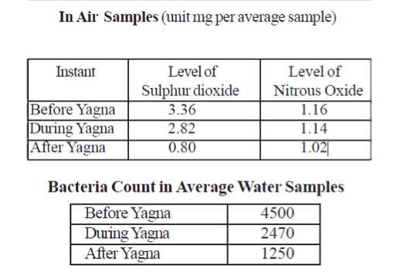

**SUBTLE ASPECTS OF YAGNA**

- Like humans, matter too, has three bodies -- physical, subtle and causal.

– Physical- body which eats, sleeps, walks, acts; which consists blood, flesh etc.

– Subtle- that which thinks, considers and controls the physical body

– Casual- that In which faith, convictions aspirations etc., are deeply rooted

The causal energy is stimulated by the rituals prescribed for theYagna performance.

In order to stimulate the causal energy, the conductor of Yagna takes all precautions to ensure that the Mantras are uttered & pronounced correctly in the proper pitch, voice, rhythm and tone.

**Mantras and Yagna**

* The collective chanting of *Mantras* in specific rhythm in front of the *Yagna* flames gives rise to unique sound waves which have infinite radiant effects in the outer space.

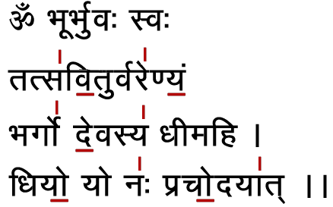

Medical Uses of Yagna

**Yagna can be Used to Treat:**

* Malaria
* Hypertension
* Diabetes
* Asthma
* Cardiac Problems
* Mental Disability
* Arthritis
* Cancer
* Aids

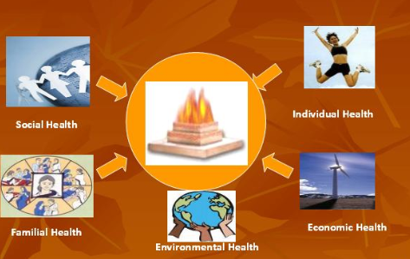

**MANTRAS – SUBTLE DIMENSIONS OF SOUND**

When a Mantra is chanted collectively during a Yagna, its sonic power increases exponentially due to:

– The collision of sound waves creates a higher frequency vibrations

-The subtle interactions of the sound waves with the cosmic energy center of the kunda

– The fundamental thermodynamic effects associated with the fumigation during the  yagna

– The compounded effects of the physical, subtle, & casual energies of the people performing the yagna.

The collective chanting of Mantras in specific rhythm in front of the Yagna flames gives rise to unique sound waves which have infinite radiant effects in the outer space.

The subtle science of syllables described in the ancient Indian scriptures classifies four levels of voice (Vani): the Baikhari, Madhyama, Para, and Pashyanti

Yagnas create a spiritually charged atmosphere, which elevates the consciousness of all living beings along with harmonizing the material systems in nature.