**Law ofKarma: As you Sow you Reap**



According to the [law of *karma*](http://www.spiritualresearchfoundation.org/articles/id/spiritualresearch/spiritualscience/lawofkarma), every positive deed generates a "merit" while every negative deed generates a "demerit" or a sin. Subsequently one has to reap the results of one’s actions. Whenever one does a good deed for another, this is bound to result in a positive return (in the form of some happiness), and this is apart from a simple "Thank you" from that person! Whenever one inflicts harm, this is bound to result in a negative return (in the form of some sorrow). It cannot be undone by a simple "Sorry"!

The law of *karma* is infallible. It is something like Newton’s third law of motion, which states that, "For every action there is an equal and opposite reaction".

Throughout our lives we are either settling an old account or creating a new one. If the account cannot be settled in this birth it is carried over to the next birth. We are not consciously aware of the give-and-take accounts generated in our previous births.

Also, the status of the relationship and the gender of the individual may change with subsequent births. So a father of a person in one birth can be born as a daughter of the same individual in the next birth.

**Who maintains the account of our Karma?**

Chitragupta - means a hidden picture that is taken of every action, thought throughout our lives like a CD in our mind.

**Three Types of Suffering Based on our Karma**

1. Mental Suffering as a result of grief, egotism, jealousy, deception, annoyance, anger
2. Physical pain – result s in genetic diseases
3. Distress caused by Natural disaster- consequence of collective sins

The following are some examples of how accounts are created and settled as one’s destiny. It also gives an understanding of how [spiritual practice](http://www.spiritualresearchfoundation.org/articles/id/aboutspiritualresearch/spiritualpractice/definition) can nullify the effects of destiny:

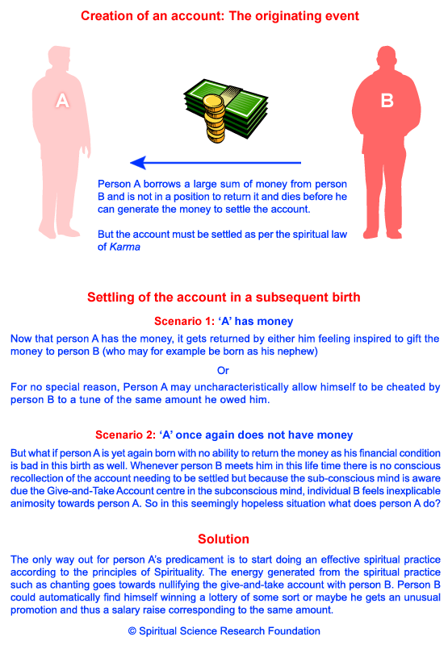

**Three Categories of Actions and Consequent Samskars:**

1. Sanchit Karma – Involuntary mental karmas
2. Prarabdha Karma – karmas done with strong emotional involvement
3. Kriyaman Karmas – Physical karma

According to the science of Spirituality, most of our family members are people with whom we have positive or negative accounts from previous births. The reason for this is that one has to be in the proximity of the other person with whom one has *karma* in order to experience either pleasure or pain.

In understanding the [law of *karma*](http://www.spiritualresearchfoundation.org/articles/id/spiritualresearch/spiritualscience/lawofkarma), we can see how Spirituality can be useful to even those of us who have absolutely no spiritual aspirations and who only wish to be immersed in worldly pursuits. Even for those worldly relations to be fruitful they need to be insulated from destiny.

# Go from many to one

The impact of our efforts is much more powerful when we concentrate our efforts on the one, instead of the many.

**Which is more effective?**

* Digging one well to access water which is 10 meters deep or digging 10 wells of 1 meter each.
* Accruing frequent flyer miles from various airlines or sticking to just one airline.

The following is how this principle works depending on the various generic paths to God.

**Path of Action (Karmayoga)**: In the initial stage, a seeker gives alms to several beggars. In the next stage, he focuses his efforts on a single cause such as a donation to a school or a hospital.

**Path of Knowledge (Dnyānyoga)**: After studying various spiritual texts from new age philosophy to religious texts, a seeker finally turns to a single one that has the most percentage of spiritual truth in it.

**Path of Devotion (Bhaktiyoga)**: A seeker progresses from worship of several Deities to that of one, goes to one place of pilgrimage rather than to many, reads one book of Holy verses rather than many.

**Path of Chanting the Name of God (Namsankirtanyoga)**: Here, the seeker chants the Name of only one Deity instead of many.

**Path of Guru’s Grace (Gurukrupāyoga)**: After visiting several Saints, a seeker finally visits only one [Guru](http://www.spiritualresearchfoundation.org/articles/id/spiritualresearch/spiritualscience/guru). Irrespective of the path of Spirituality one follows, spiritual progress does not really occur beyond a certain level without the grace of a Guru.

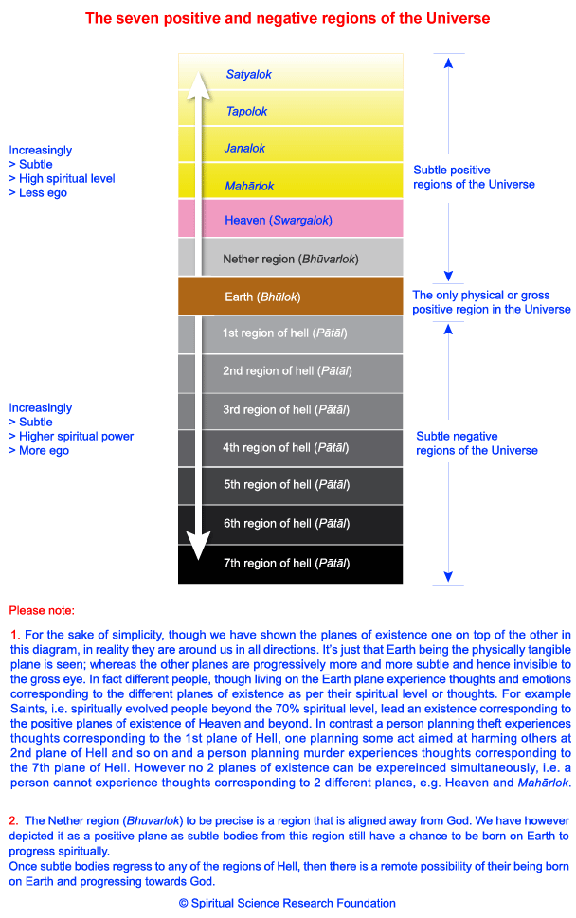

**Important Goal of this Life:**

By and large, every one wants to live their life such that their next few lives will be very happy. But the aim of life is not to have happy future births, but rather to get out of the cycle of births and deaths. The reason that we are born is that we haven’t yet learnt the lessons that we were meant to learn and so just as we have to repeat a class if we fail our exams – likewise we have to be born over and over again. Being liberated from the drudgery of this unending cycle can happen in this very birth if we make an effort to grow spiritually and realise God. This is the supreme spiritual goal any man can have.

The importance of the Earth plane of existence:

The Earth plane of existence is very important. It is the only plane of existence where we can make rapid spiritual growth and settle our give-and-take account in the shortest period of time. The main reason for this is that with the help of the physical body, we can do many things to enhance our spiritual growth and spiritual level and reduce the basic subtle *Tama* component.

Other than Earth, spiritual growth is mostly likely to occur only in the regions beyond Heaven such as *Maharloka* etc. This is because in Heaven, the subtle bodies run the risk of getting caught up in the unending pleasures it offers. In the Nether and Hell planes of existence, the punishment is so severe and also the distress from the other higher-level ghosts is such that it becomes very difficult to rise above the suffering to undertake any spiritual practice of value.

Seven positive planes of existence: The planes of existence occupied mostly by living persons and subtle bodies doing righteous deeds and engaged in spiritual practice according to the positive path of spiritual practice are known as the seven positive planes of existence or *saptalok*. By positive path, we mean the orientation of spiritual practice is towards God-realisation, which is the ultimate in spiritual growth.

The Earth plane is the only physical plane of existence in the Universe and is also the first plane of existence in the hierarchy of the positive planes of existence in the Universe.

**Seven Negative planes of existence:** These are planes of existence occupied mostly by subtle bodies that have done unrighteous deeds and are engaged in spiritual practice according to the negative path. By negative path, we mean the orientation of spiritual practice is towards attaining spiritual power, e.g. supernatural powers. This spiritual power is primarily used to enhance one’s control over others or for negative purposes.

**Importance of the mental state at the time of death**

The mental state at the point of death, apart from what has been mentioned above, is very important. Our mental state is generally relative to the proportion of the subtle basic components in our being.

If a person is actually doing his spiritual practice such as [chanting the Name of God](http://www.spiritualresearchfoundation.org/aboutspiritualresearch/chanting/) at the time of death then the influence of desires, attachments, ghosts, etc. are minimal possible for that person compared to his state when not chanting. This makes his subtle body lighter. Hence, if he passes away while chanting, he attains better plane of existence among the sub-planes than what he would have attained were he to pass away without chanting.

At the time of death, if a person is chanting the Name of God and is also in a state of surrender to God’s will, then he attains an even better plane of existence in his life after death and his sojourn is undertaken with lightening speed. This is because the person being in a state of surrender on Earth plane of existence itself, has very less chance of increasing his ego in his life after death. Also, the entire responsibility of his well-being in his life after death is undertaken by his [evolved spiritual guide (Guru)](http://www.spiritualresearchfoundation.org/spiritualresearch/spiritualscience/guru/).